SANDBACH UNITED FOOTBALL CLUB CIO
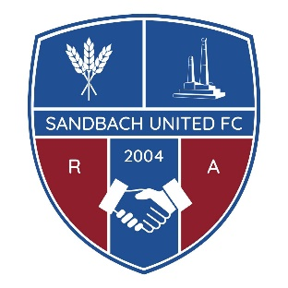

Job Description
TITLE OF THE POST
Community Officer

REPORTS TO:
Chairman

PURPOSE OF ROLE:
The Community Officer will work to engage the local community in becoming involved in the football and social activities at Sandbach United FC with a focus on supporting the needs of the local population.
MAIN TASKS SUMMARY

Building relationships: Connect with the Local Authority, Town Council, Community & Voluntary Services (Cheshire East), local schools and colleges, community, voluntary, faith and social enterprise organisations, and the local population to promote the use of Sandbach United as a venue for football, wider sporting, social and health and wellbeing activities. This role has the dual aim of promoting community benefit and generating additional revenue for the Club.

Planning and Hosting Events: Leading on the delivery of community-based events using Sandbach United as a base and also engaging SUFC in wider community events taking place in the local area.

Recruiting participants: Ensuring our community events are well promoted and attended to bring benefits for the community and the club.

Monitoring and reporting: Track the success of events and report on their outcomes including monitoring how the Club is performing in terms of accessing diverse communities.

Promoting opportunities: Highlight the benefits of playing football and the opportunities available through the organisation.

Diversity and Inclusion: Support the Disability Lead in ensuring we plan for and deliver both a football and social experience where disabled people have access to all opportunities and feel they truly belong, both on and off the pitch. Engage with the wider population to include all protected characteristics to ensure SUFC is a fully inclusive and accessible Club. E.g.: LGBTQ+, older people, people experiencing poverty etc.

PROJECT AREA
Community, Diversity and Inclusion

BASED AT
SUFC, Hind Heath Road, Sandbach, Cheshire, CW11
BENEFITS
Reduced membership fees for children enrolled in the Club.
MINIMUM NUMBER OF HOURS REQUIRED
To be determined
DAYS AND TIMES OF DAY REQUIRED
To be determined. Will include both evening and weekend attendance as required for the role.
AGE/GENDER RESTRICTIONS
None
ANY SPECIAL TRAINING OFFERED
Relevant training for Committee Members will be available

SUFC POLICIES WILL APPLY
All policies are available on the SUFC Website
ACCESS
SUFC is wheelchair accessible, and the building is all on flat level. There is a car park to the front of the building including disabled parking bays and access
SUPPORT
The Board of Trustees will provide team support as necessary.
KEY PERSON TO CONTACT FOR MORE INFORMATION

Simon Tillott – Club Chairman at chair@sandbachunitedfc.co.uk

